Project Design Phase-I
Solution Architecture

Parameter | Details
Date | 08 March 2026
Team ID
Project Name | VoltEdge: EV Analytics Portal
Maximum Marks | 4 Marks

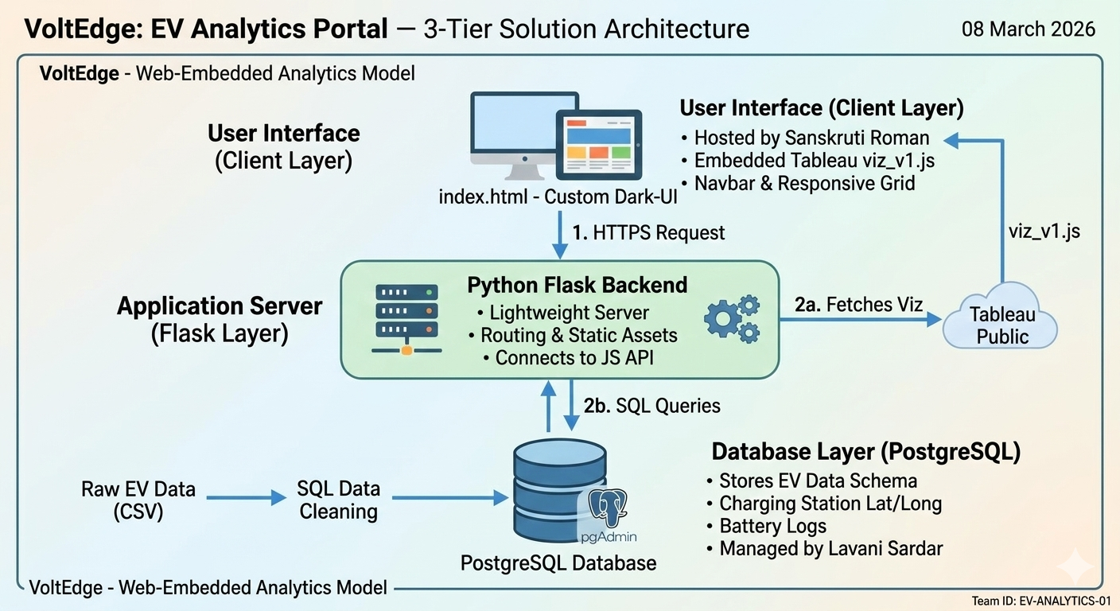

1. Solution Architecture Overview
The VoltEdge architecture is a modern data-to-web pipeline designed for rapid deployment and high interactivity. It bridges the gap between raw automotive data stored in PostgreSQL and an interactive user experience delivered via a Flask web application.
Architecture Goals:
- Centralized Data: Using PostgreSQL to manage complex EV datasets (charging logs, vehicle specs) with relational integrity.
- Embedded Analytics: Utilizing the Tableau JavaScript API to deliver interactive dashboards within a custom, branded UI.
- Unified Portal: Providing a single point of access for distinct stakeholders like Aarav (Planner) and Meera (Fleet Manager).

2. Solution Architecture Diagram
The architecture follows a specialized Web-Embedded Analytics Model.
- Database Layer (PostgreSQL):
  - Stores structured tables for EV specifications, charging station coordinates (Latitude/Longitude), and battery performance logs.
  - Lavani Sardar managed the schema design and SQL query optimizations to ensure fast data retrieval.
- Visualization Layer (Tableau Public):
  - Processes raw data into 11 unique visualizations.
  - Dashboards are published to Tableau Public and served via the Tableau JavaScript API (viz_v1.js).
- Application Layer (Flask & HTML/CSS):
  - The VoltEdge Portal acts as the presentation layer.
  - Sanskruti Roman implemented a responsive grid layout to host the Tableau objects securely and efficiently.

3. Detailed Component Interaction (Request Flow)
- Request: A user opens the VoltEdge portal (index.html) in their browser.
- Web Serving: The Flask backend serves the static assets and the main page structure.
- Visualization Fetch: The browser executes the Tableau embedding script. This script fetches the interactive dashboards from the server using the unique viz identifiers.
- Data Rendering: The dashboards display data previously synced and cleaned within the PostgreSQL environment.
- User Interaction: When a user clicks a filter (e.g., "BodyStyle" or "Brand"), the Tableau object updates dynamically within the portal without a full page refresh.

4. Technology Stack Selection Justification
- PostgreSQL: Chosen for its superior ability to handle relational data and its industry-standard compatibility with BI tools.
- Tableau Embed API: Used to provide professional-grade interactivity (heatmaps and tooltips) that matches the high-end look of the VoltEdge UI.
- Flask (Python): Provides a lightweight, scalable server-side environment perfect for routing and hosting embedded analytics.

5. Team Contributions to Architecture
- Lavani Sardar: Implementation of the PostgreSQL database and the core Tableau-to-Web embedding logic.
- Sanskruti Roman (Team Lead): Frontend UI design, Navbar structure, and overall architecture coordination.
- Sanskruti Sawant & Sayali Firake: Data validation, styling the CSS for the dashboard containers, and ensuring cross-device responsiveness.

